1. Use a for loop to print the numbers 1 through 100
2. Use a while loop to print the numbers 1 through 100
3. Use either type of loop to print every 5 numbers between 0 and 25.

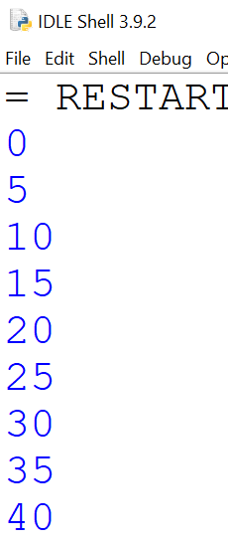

1. Create a loop that rolls a six-sided dice 10 times

You can use either a for loop or while loop

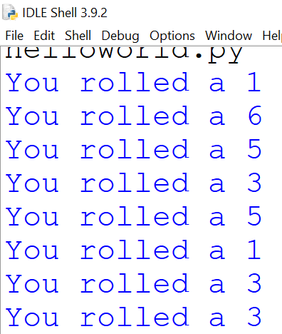

1. Create a program that asks users the author of Romeo and Juliet.  
   If the answer correctly, exit the program (with a break)

If they answer correctly, let them try again

1. Create a list with 4 grocery store items. Loop through list printing each items is $1

